What shots should you get on your wedding video?

Exterior shots of the church or wedding venue

A marquee or sign with the wedding information posted

Guests arriving and entering the wedding venue

Wide shot of the auditorium or wedding venue as guests enter

Stained glass windows

Flower arrangements

Candles

Pre-Ceremony Shot List

Backstage bride & bridesmaids

Backstage groom & groomsmen

Three or four minutes of ceremonial music to use later for background

Grandparents being seated

Groom's parents being seated

Bride's mom being seated

The lighting of the "unity" candle

The couple reciting their vows

The exchange of rings

The pronouncement by the minister that the couple is now husband and wife

The first kiss

Ceremony Coverage

Groom's arrival at altar

Processional
What shots should you get on your wedding video?

Bridesmaids and Groomsmen

Bride's procession

Dad "giving away" bride

Opening prayer

Ceremony coverage

Music performances

Recessional

Bride and Groom Departure for the reception

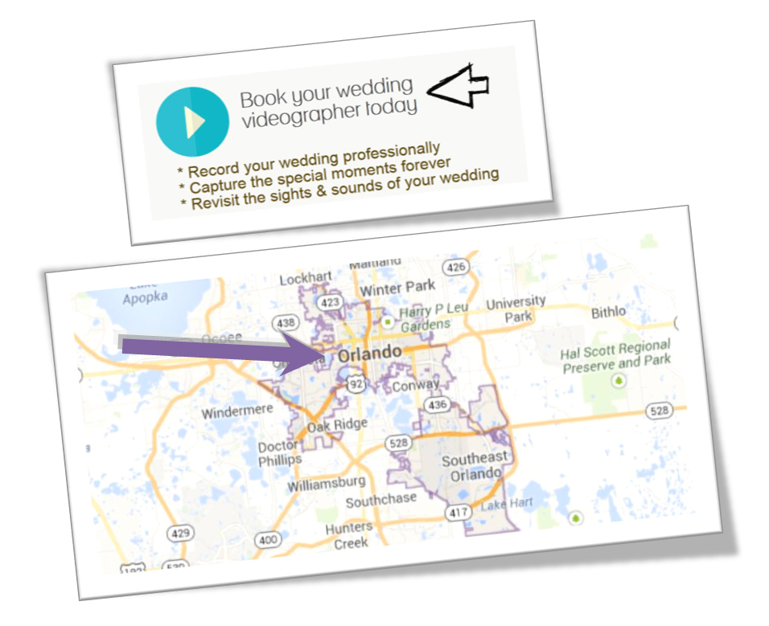
Getting married in Orlando, Florida?
Visit: http://orlandobrideguide.com for information to help you plan your dream wedding.

